Assignment 1
24K-0024

Q1

transactionLog = [
{'orderId': 1001, 'customerId': 'cust_Ahmed', 'productId': 'prod_10'},
{'orderId': 1001, 'customerId': 'cust_Ahmed', 'productId': 'prod_12'},
{'orderId': 1002, 'customerId': 'cust_Bisma', 'productId': 'prod_10'},
{'orderId': 1002, 'customerId': 'cust_Bisma', 'productId': 'prod_15'},
{'orderId': 1003, 'customerId': 'cust_Ahmed', 'productId': 'prod_15'},
{'orderId': 1004, 'customerId': 'cust_Faisal', 'productId': 'prod_12'},
{'orderId': 1004, 'customerId': 'cust_Faisal', 'productId': 'prod_10'},
]
productCatalog = {
'prod_10': 'Wireless Mouse',
'prod_12': 'Keyboard',
'prod_15': 'USB-C Hub',
}
def processTransactions(transactionsList) :
d1 = {}
for x in transactionsList:
customer = x['customerId']
product = x['productId']
if customer not in d1:
d1[customer] = set()

d1[customer].add(product)
return d1
def findFrequentPairs(customerData):
customer_products = {}
for x in customerData:
customer = x['customerId']
product = x['productId']
if customer not in customer_products:
customer_products[customer] = set()
customer_products[customer].add(product)
pairs = {}
for products in customer_products.values():
products_list = list(products)

for x in range(len(products_list)):
for y in range(x + 1, len(products_list)):
p1 = products_list[x]
p2 = products_list[y]
if p1 < p2:
pair_key = (p1, p2)
else:
pair_key = (p2, p1)
if pair_key in pairs:
pairs[pair_key] += 1
else:
pairs[pair_key] = 1
return pairs
def getRecommendations(targetProductId, frequentPairs):
recommendations = {}

for pair, count in frequentPairs.items():
p1 , p2 = pair
if targetProductId == p1:
other = p2
elif targetProductId == p2:
other = p1
else:
continue
if other in recommendations:
recommendations[other] += count
else:
recommendations[other] = count
ranked = sorted(recommendations.items(), key=lambda x: x[1], reverse=True)
return ranked

def generateReport(targetProductId, recommendations, catalog):
if not recommendations:
print("No co-purchase data available.")
return
product_ids, counts = zip(*recommendations)
for i, (pid, count) in enumerate(zip(product_ids, counts), start=1):
print(f"{i}. {catalog.get(pid, pid)} (co-purchased {count} times)")
result = processTransactions(transactionLog)
print(result)
pairs = findFrequentPairs(transactionLog)
print(pairs)
recommendations = getRecommendations('prod_15', pairs)
print("Recommnendations for product 15: ", recommendations)
recommend = [('prod_12', 2), ('prod_15', 2)]
generateReport('prod_12', recommend, productCatalog)

OUTPUT:
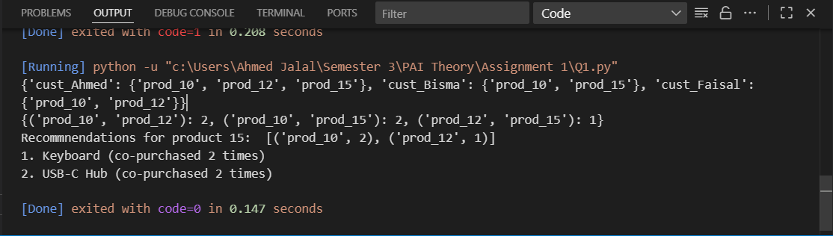

Q2
allPosts = [
{'id': 1, 'text': 'I LOVE the new #GuiPhone! Battery life is amazing.'},
{'id': 2, 'text': 'My #GuiPhone is a total disaster. The screen is already broken!'},
{'id': 3, 'text': 'Worst customer service ever from @GuPhoneSupport. Avoid this.'},
{'id': 4, 'text': 'The @GuPhoneSupport team was helpful and resolved my issue. Great service!'},
]

PUNCTUATION_CHARS = '!"#$%&\'()*+,-./::<=>?@[\\]^_`{|}~'
STOPWORDS_SET = {'i', 'me', 'my', 'a', 'an', 'the', 'is', 'am', 'was', 'and', 'but', 'if', 'on', 'to', 'of', 'at', 'by', 'for', 'with', 'this', 'that'}
POSITIVE_WORDS_SET = {'love', 'amazing', 'great', 'helpful', 'resolved'}
NEGATIVE_WORDS_SET = {'disaster', 'broken', 'worst', 'avoid', 'bad'}

def preProcessText(text, punctuationList, stopWordsSet):
new_text = ""
result_text = ""
text = text.lower()

for x in text:
if x not in punctuationList:
new_text += x
words = new_text.split()
for word in words:
if word not in stopWordsSet:
result_text += word
result_text += " "
return result_text

def analyzePosts(postsList, punctuation, stopwords, positive, negative):
cleaned_posts = list(map(lambda post: preProcessText(post['text'], punctuation, stopwords), postsList))
score = 0
new_list = []

for i in range(len(postsList)):
text = cleaned_posts[i]
words = text.split()
score = 0
for word in words:
if word in positive:
score += 1
elif word in negative:
score -= 1
new_list.append({
'id': postsList[i]['id'],
'text': postsList[i]['text'],
'processedText': text.strip(),
'score': score
})
return new_list

def getFlaggedPosts(scoredPosts, sentimentThreshold=-1):
return [post for post in scoredPosts if post['score'] <= sentimentThreshold]
def findNegativePosts(flaggedPosts):
posts = {}
for post in flaggedPosts:
text = post['text']
for word in text.split():
for ch in word:
if ch == "@" or ch == "#":
if word not in posts:
posts[word] = 0
posts[word] += 1
return posts

text = "PAI is kesy !@ (prhen?"
result = preProcessText(text, PUNCTUATION_CHARS, STOPWORDS_SET)
print(result)

results = analyzePosts(allPosts, PUNCTUATION_CHARS, STOPWORDS_SET, POSITIVE_WORDS_SET, NEGATIVE_WORDS_SET)
for r in results:
print(r)
fposts = getFlaggedPosts(results)
for f in fposts:
print (f)
nposts = findNegativePosts(fposts)
print(nposts)

OUTPUT:
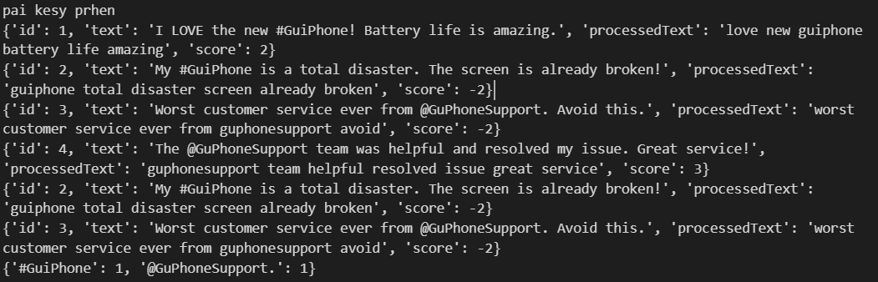

Q3
check_status = ['idle', 'delivering', 'charging']

class Package:
def __init__(self, packageId, weightInKg):
self.packageId = packageId
self.weightInKg = weightInKg

class Drone:
def __init__(self, droneId, maxLoadInKg, status):
self.droneId = droneId
self.maxLoadInKg = maxLoadInKg
self.__status = status
self.assigned_package = None
self.delivery_timer = 0

def get_status(self):
return self.__status

def set_status(self, newStatus):
if newStatus.lower() not in check_status:
print("Enter valid status")
return
self.__status = newStatus.lower()

def assign_package(self, packageObj):
if self.__status == 'idle' and packageObj.weightInKg <= self.maxLoadInKg:
self.assigned_package = packageObj
self.set_status('delivering')
self.delivery_timer = 2
print(f"Drone {self.droneId} assigned package {packageObj.packageId}")
return True
else:
print(f"Drone {self.droneId} cannot take package {packageObj.packageId}")
return False

class FleetManager:
def __init__(self):
self.drones = {}
self.pending_packages = []
self.current_pkg_index = 0 #

def add_drone(self, droneId, maxLoadInKg, status):
index = len(self.drones)
self.drones[index] = Drone(droneId, maxLoadInKg, status)

def add_package(self, packageObj):
self.pending_packages.append(packageObj)

def dispatchJobs(self):

for drone in self.drones.values():
if (drone.get_status() == 'idle' and
self.current_pkg_index < len(self.pending_packages)):

pkg = self.pending_packages[self.current_pkg_index]
if drone.assign_package(pkg):
self.current_pkg_index += 1

def simulationTick(self):
for drone in self.drones.values():
if drone.get_status() == 'delivering':
drone.delivery_timer -= 1
if drone.delivery_timer <= 0:
drone.assigned_package = None
drone.set_status('charging')
elif drone.get_status() == 'charging':
drone.set_status('idle')

packages = [
Package(3412, 10),
Package(3532, 6.4),
Package(4523, 2.5),
Package(3112, 7.3),
Package(6456, 8)
]

fm = FleetManager()
fm.add_drone(6543, 10, 'idle')
fm.add_drone(9041, 5, 'charging')
fm.add_drone(4523, 8, 'delivering')
fm.add_drone(4745, 6, 'idle')

for pkg in packages:
fm.add_package(pkg)

fm.dispatchJobs()
fm.simulationTick()

OUTPUT

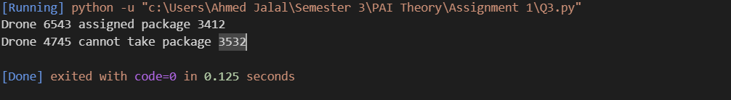

Q4
originalPixels = [[10, 20, 30], [40, 50, 60]]

class Image:
def __init__(self, pixelList):
self.pixels = pixelList

def applyTransformation(self, transformationFunc):
self.pixels = transformationFunc(self.pixels)

def getCopy(self):
return [row[:] for row in self.pixels]

def flipHorizontal(pixelData):
return [row[::-1] for row in pixelData]

def adjustBrightness(pixelData, brightnessValue):
for i in range(len(pixelData)):
for j in range(len(pixelData[0])):
pixelData[i][j] += brightnessValue
return pixelData

def rotateNinetyDegrees(pixelData):
rows = len(pixelData)
cols = len(pixelData[0])
return [[pixelData[rows - j - 1][i] for j in range(rows)] for i in range(cols)]

class AugmentationPipeline:
def __init__(self):
self.functionList = []

def addStep(self, transformFunc):
self.functionList.append(transformFunc)

def processImage(self, originalImage):
results = []
for step in self.functionList:
imgCopy = Image(originalImage.getCopy())
imgCopy.applyTransformation(step)
results.append(imgCopy.pixels)
return results

img = Image(originalPixels)

pipeline = AugmentationPipeline()

pipeline.addStep(flipHorizontal)
pipeline.addStep(lambda pixels: adjustBrightness(pixels, 10))
pipeline.addStep(rotateNinetyDegrees)

augmentedImages = pipeline.processImage(img)

for i, imgData in enumerate(augmentedImages, 1):
print("\nTransformation", i)
for row in imgData:
print(row)

